

Submitted by: Muhammad Raffey
Submitted to: Sir Nouman
Sap ID: 70153209
Department: CS
Section: 4G
Assignment no: 2

Question 1:
Write a C++ program to implement the UNDO system using a Stack implemented with an
Array.
Code:
#include <iostream>
#include <string>
using namespace std;

class Stack
{
string arr[100];
int top;

public:
Stack()
{
top = -1;
}
bool isEmpty()
{
return top == -1;
}
void push(string word)
{
arr[++top] = word;
}
void pop()
{
if (isEmpty())
{
cout << "Nothing to undo." << endl;
return;
}
cout << "Undo performed. Removed: " << arr[top--] << endl;
}
void display()
{
if (isEmpty())
{
cout << "Text is empty." << endl;
return;
}
cout << "Current text:\n----------------------------------------\n ";
for (int i = 0; i <= top; i++)
{
cout << arr[i] << "\n";
}
cout << "\n------------------------------------------\n";
}
};

int main()
{
Stack s;
int choice;
string word;

while (true)
{
cout << "1. Add a word (Push)" << endl;
cout << "2. Perform Undo (Pop)" << endl;
cout << "3. Display current text" << endl;
cout << "4. Exit" << endl;
cout << "Choose an option: ";
cin >> choice;

if (choice == 1)
{
cout << "Enter a word: ";
cin >> word;
s.push(word);
}
else if (choice == 2)
{
s.pop();
}
else if (choice == 3)
{
s.display();
}
else if (choice == 4)
{
break;
}
}
return 0;}
Output:
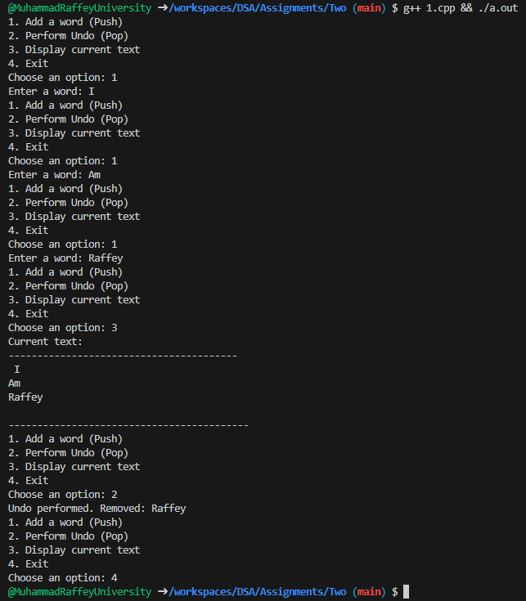
Question 2:
A hospital wants to develop an Emergency Check-In System to manage incoming patients.
Patients are treated on a first-come, first-served basis, but each patient record must store detailed
Information.
Code:
#include <iostream>
#include <string>
using namespace std;

class Patient
{
public:
int patient_id;
string name;
int age;
string symptoms;
Patient *next;

Patient(int id, string n, int a, string s) : patient_id(id), name(n), age(a), symptoms(s), next(NULL) {}
};

class Queue
{
Patient *front, *rear;

public:
Queue()
{
front = rear = NULL;
}

bool isEmpty()
{
return front == NULL;
}

void enqueue(int patient_id, string name, int age, string symptoms)
{
Patient *newPatient = new Patient(patient_id, name, age, symptoms);
if (rear == NULL)
{
front = rear = newPatient;
cout << "Patient Added: " << name << endl;
return;
}
rear->next = newPatient;
rear = newPatient;
cout << "Patient Added: " << name << endl;
}

void dequeue()
{
if (isEmpty())
{
cout << "No patients waiting for treatment." << endl;
return;
}
Patient *temp = front;
cout << "Treating Patient: " << front->name << endl;
front = front->next;
if (front == NULL)
{
rear = NULL;
}
delete temp;
}

void frontPatient()
{
if (isEmpty())
{
cout << "No patients waiting for treatment." << endl;
return;
}
cout << "Next Patient to Treat:" << endl;
cout << "ID: " << front->patient_id << ", Name: " << front->name << ", Age: " << front->age << ", Symptoms: " << front->symptoms << endl;
}

void display()
{
if (isEmpty())
{
cout << "No patients waiting for treatment." << endl;
return;
}
cout << "Current Emergency Queue:" << endl;
Patient *current = front;
while (current != NULL)
{
cout << current->patient_id << " - " << current->name << " (" << current->age << ") - " << current->symptoms << endl;
current = current->next;
}
}
};

int main()
{
Queue q;

q.enqueue(101, "Ahmed", 45, "Chest pain");
q.enqueue(102, "Sonia", 30, "High fever");
q.enqueue(103, "Bilal", 60, "Breathing difficulty");

q.dequeue();

q.enqueue(104, "Mina", 28, "Migraine");
q.enqueue(105, "Zaid", 50, "High blood pressure");

q.frontPatient();

q.display();

return 0;
}
Output:
